React Native Expo Project
Progress Log
Student Name: ____Katellyn Hyker____________________________________
App Name: ______InnerBloom__________________________________

Progress Made

Set up and completed firebase implementation
Added buttons for edit and deleting
Implemented firebase into all necessary buttons

Design Updates
Include screenshots or images of your app screens below.
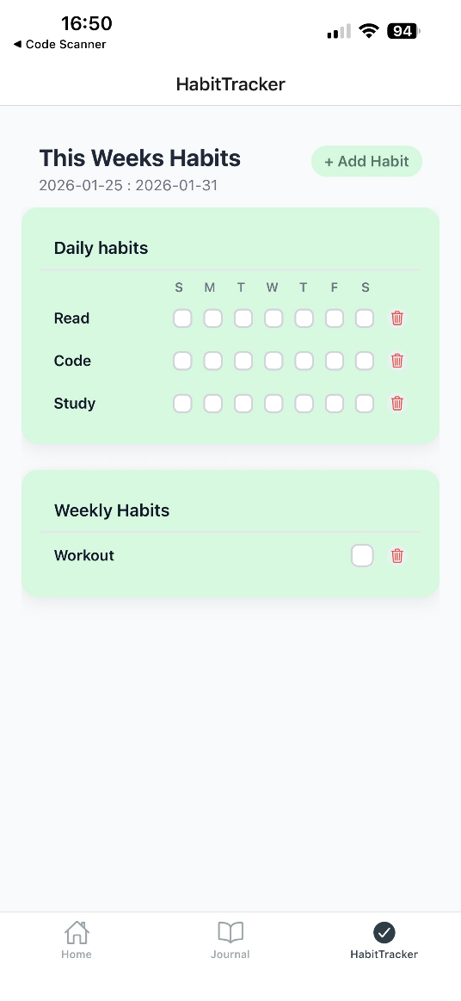
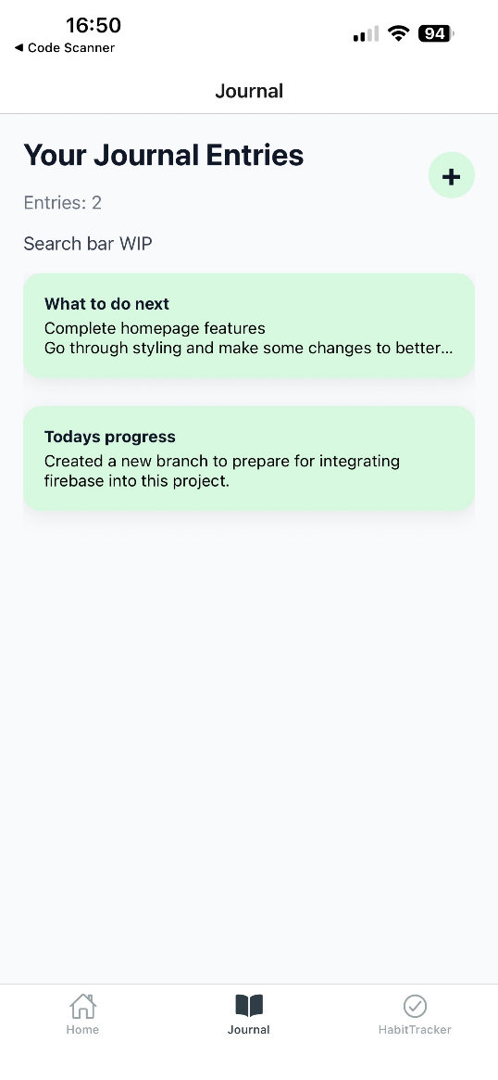
Issues / Blockers

No new issues.
Main blockers:
Uncertainty for additional homescreen feature
Trying to figure out what additional features could be added on time.
Next Steps

List what needs to be finished
Finish homescreen functionality
Consider which features may be reasonable to add in the timeline

